Name: Nam Jun Lee

WSU ID: 011606459

Assignment: Extra Assignment

Class number: 2021 Fall-MIS-325-ONLIN-2217-H72-01-10356-LEC

Date: December 6th , 2021

<https://cb-ot-devst06.ad.wsu.edu/MF13namjun.lee/ExtraAssignment/ExtraAssignment.aspx>

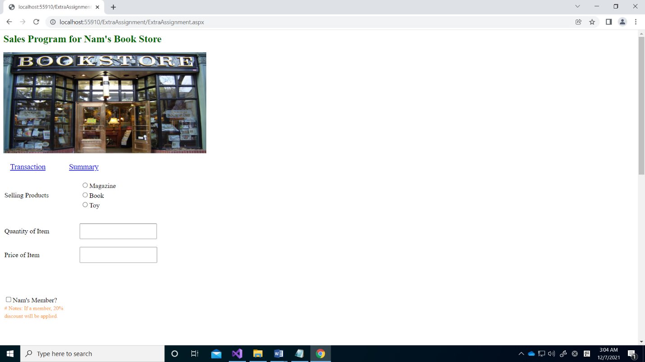

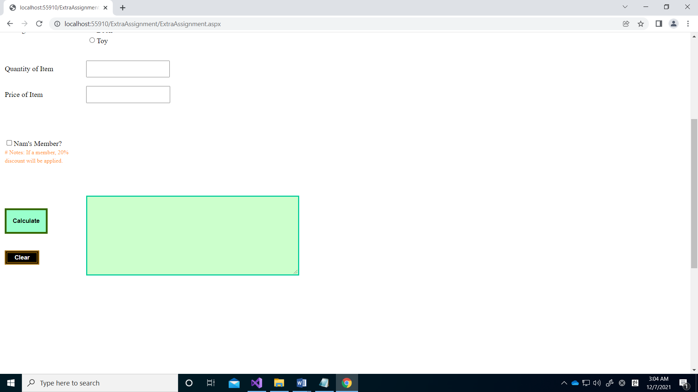

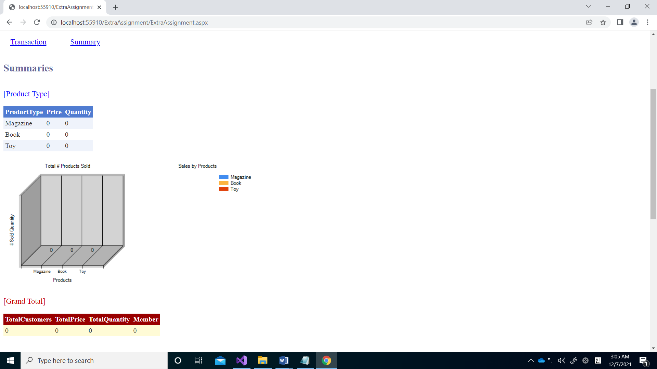

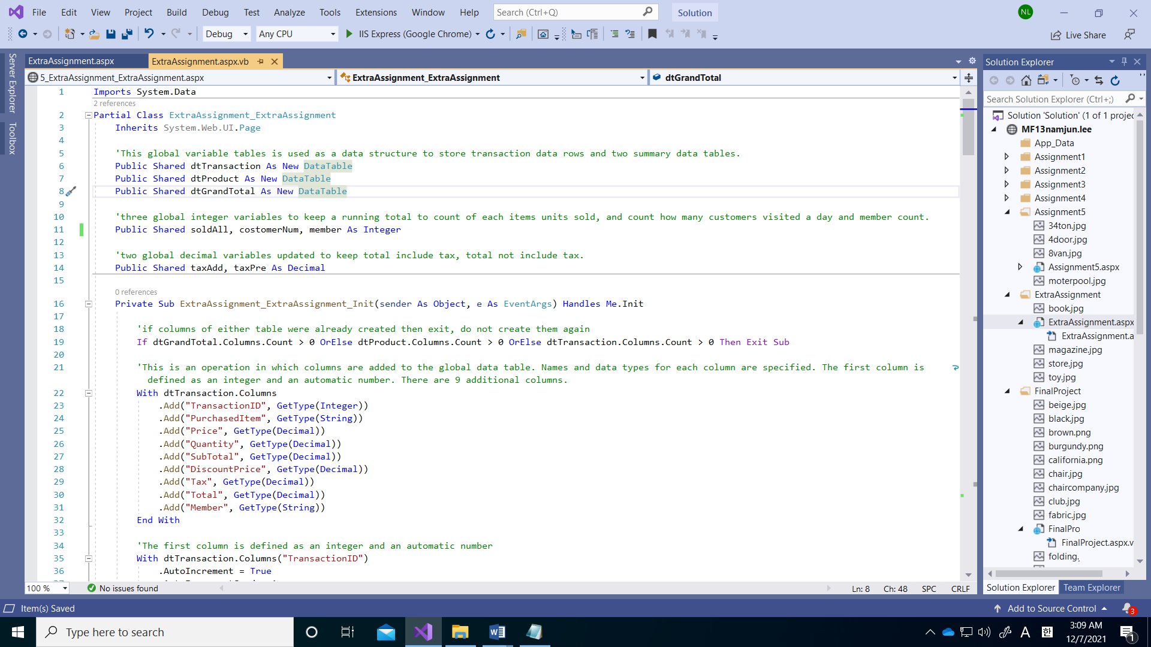

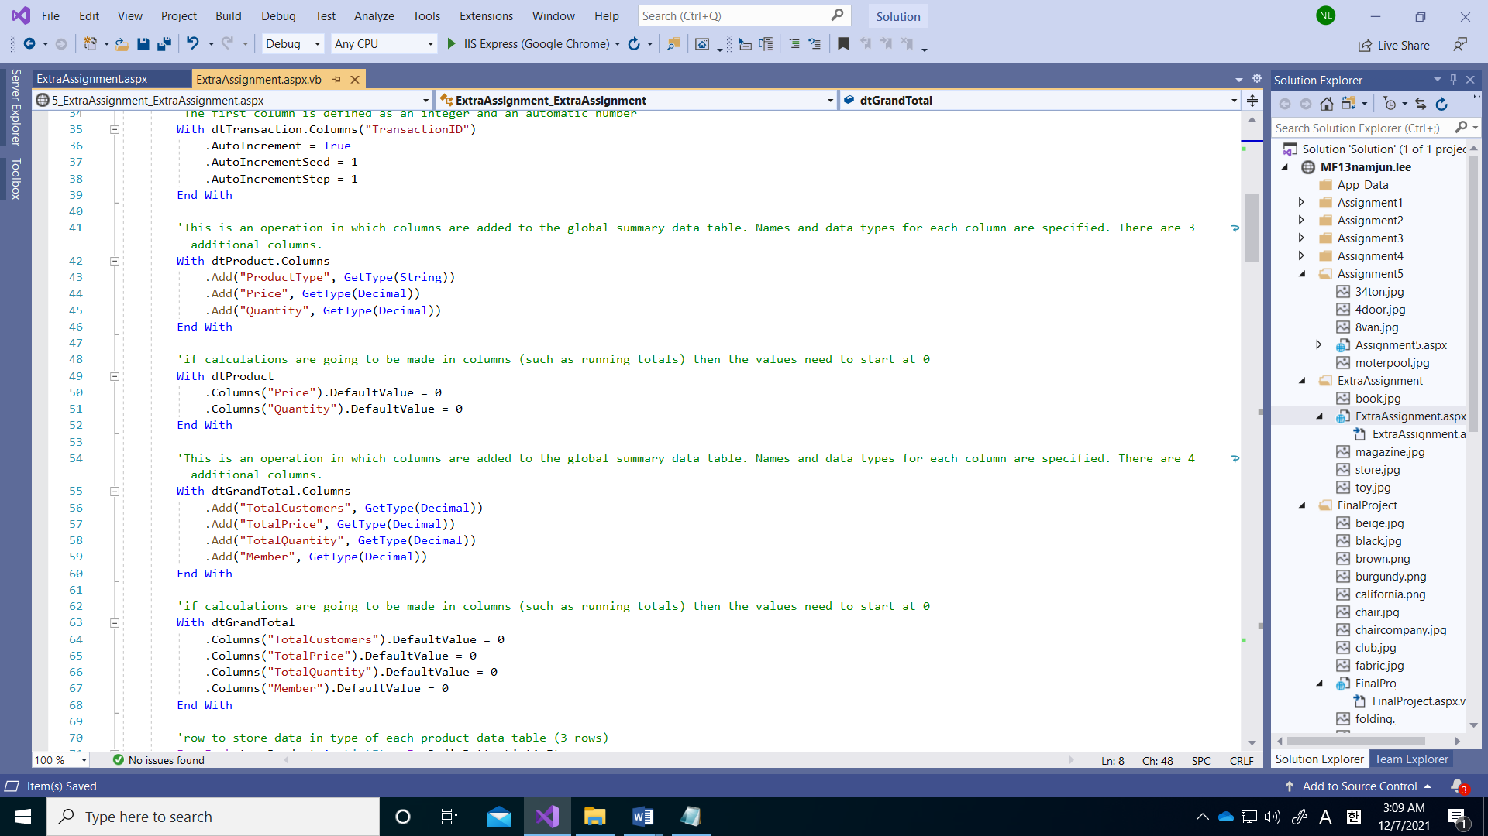

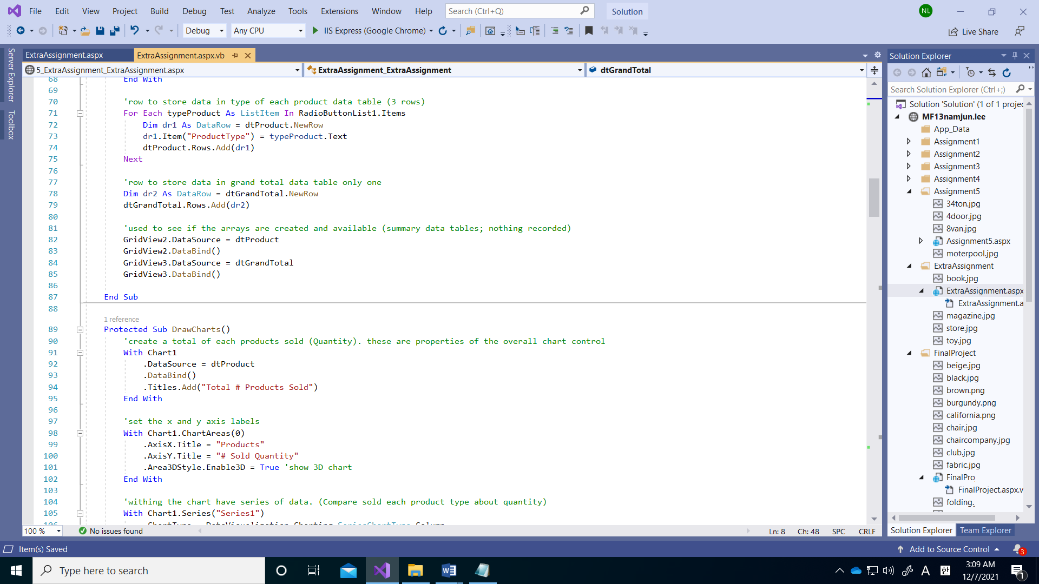

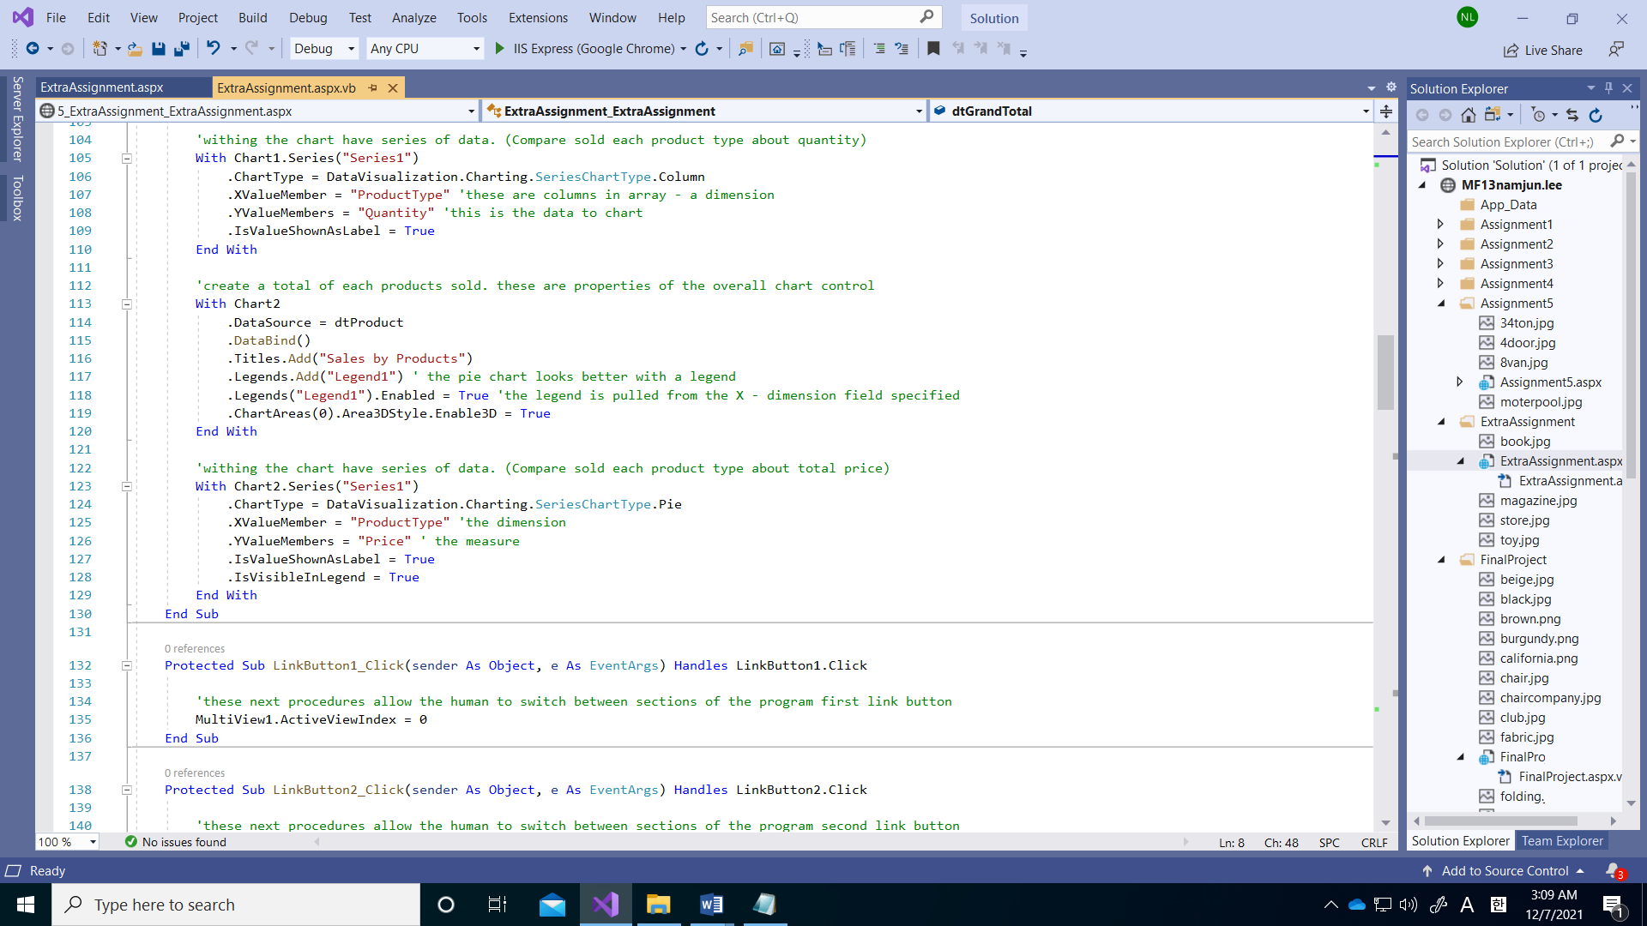

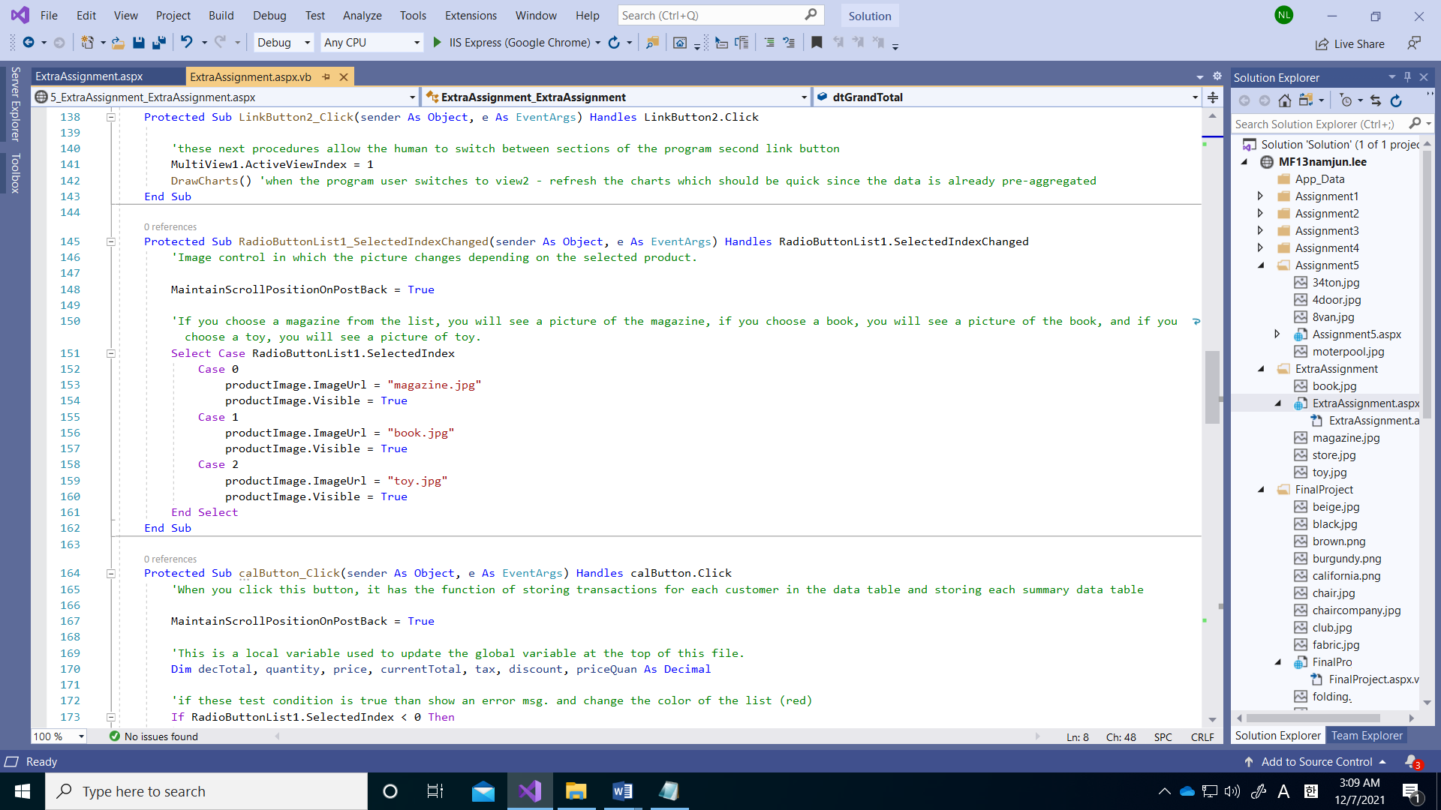

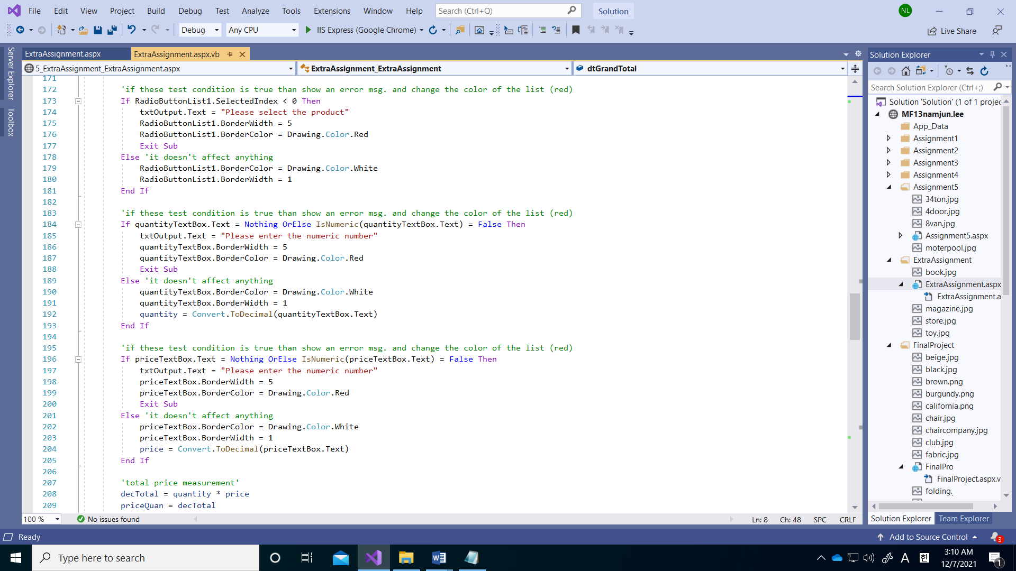

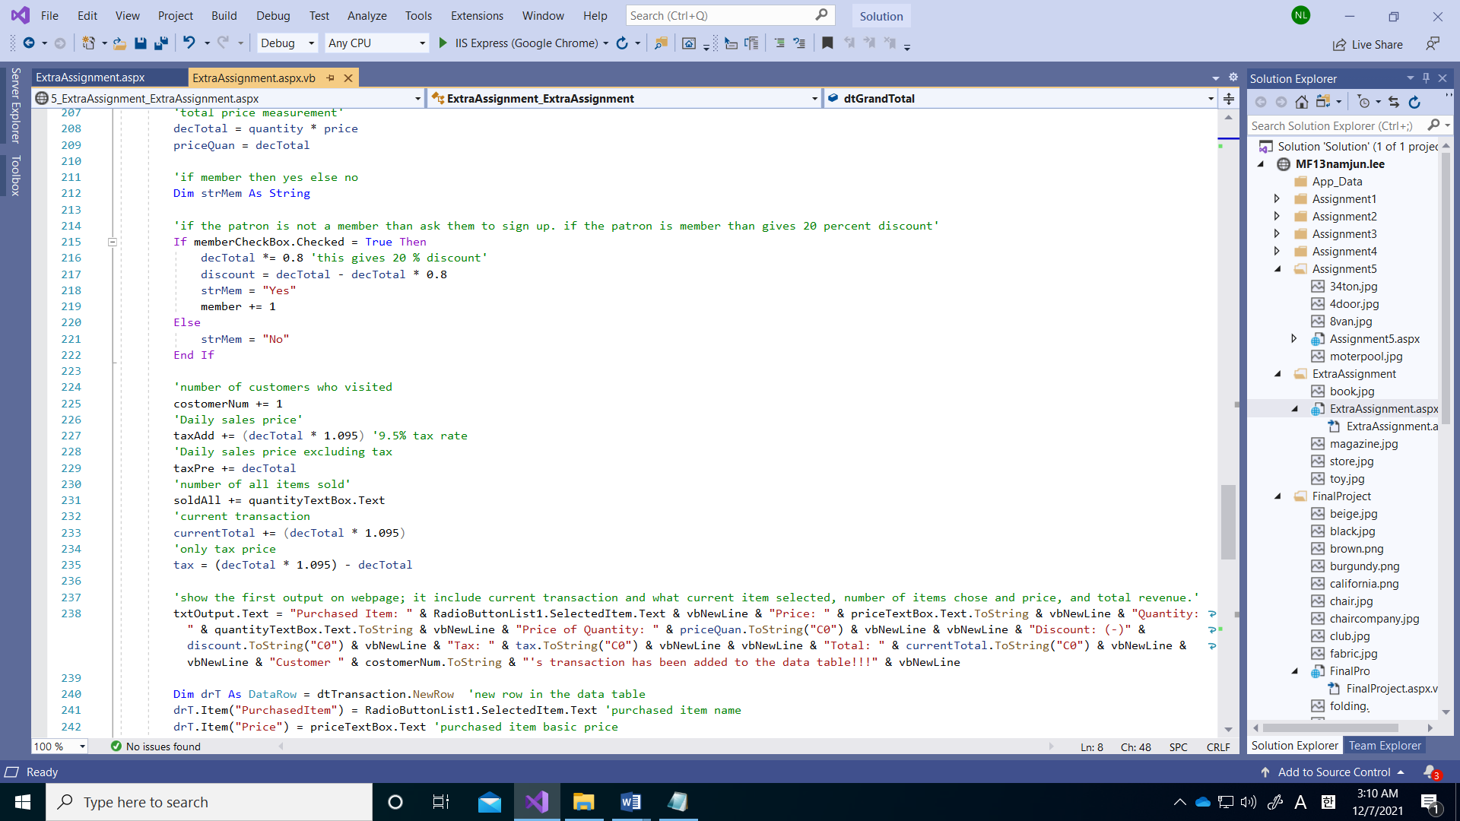

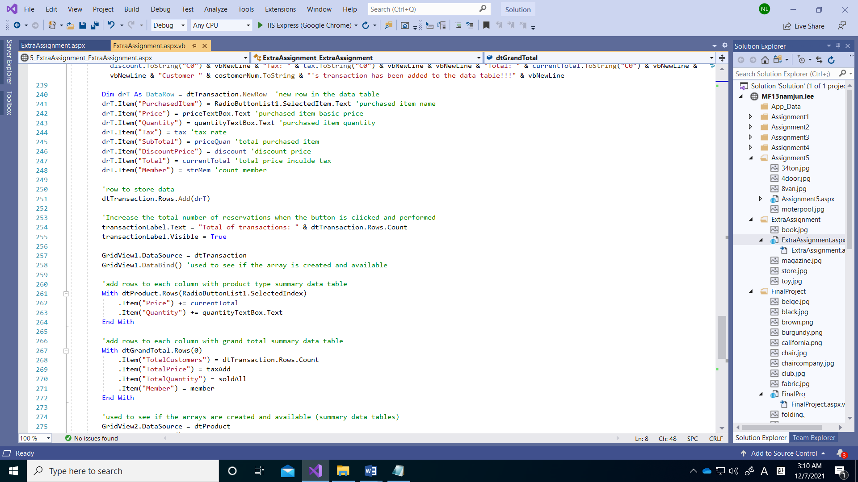

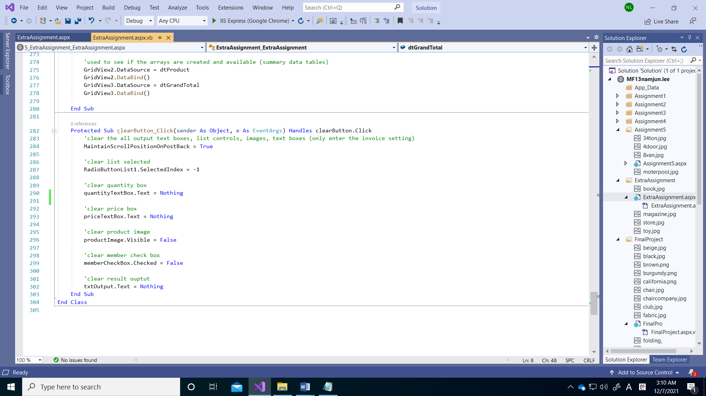

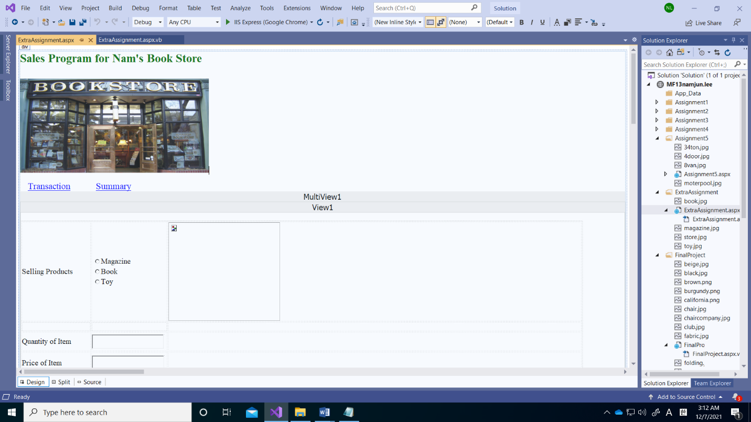

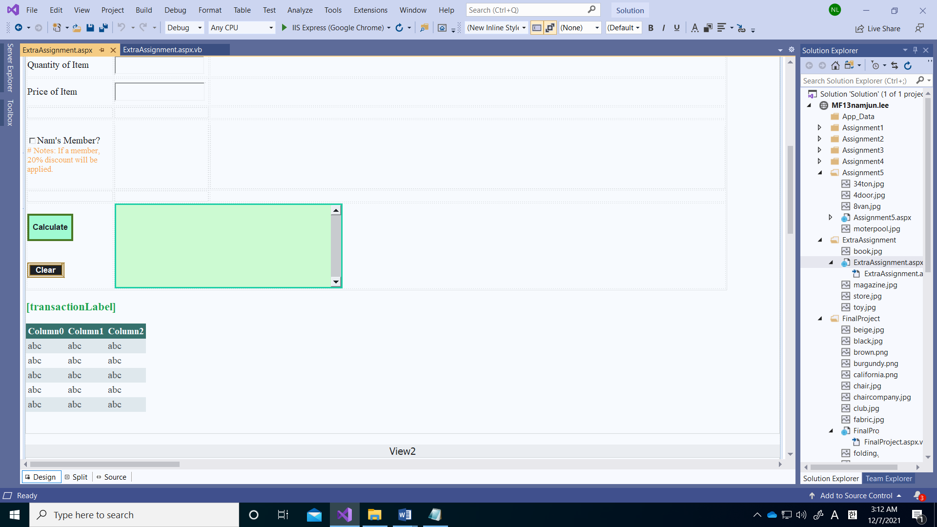

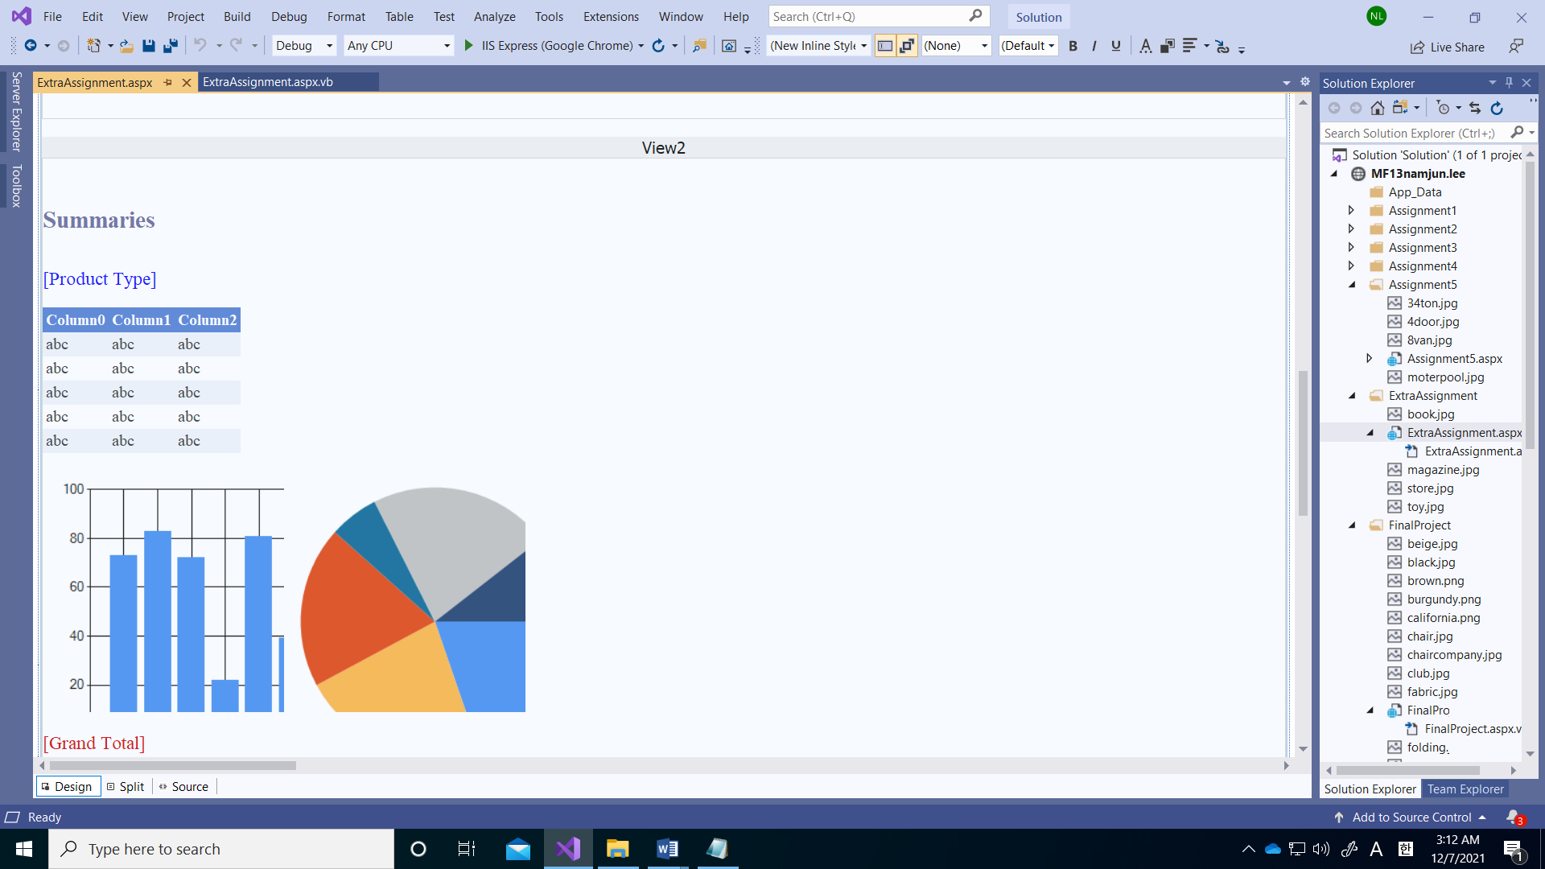

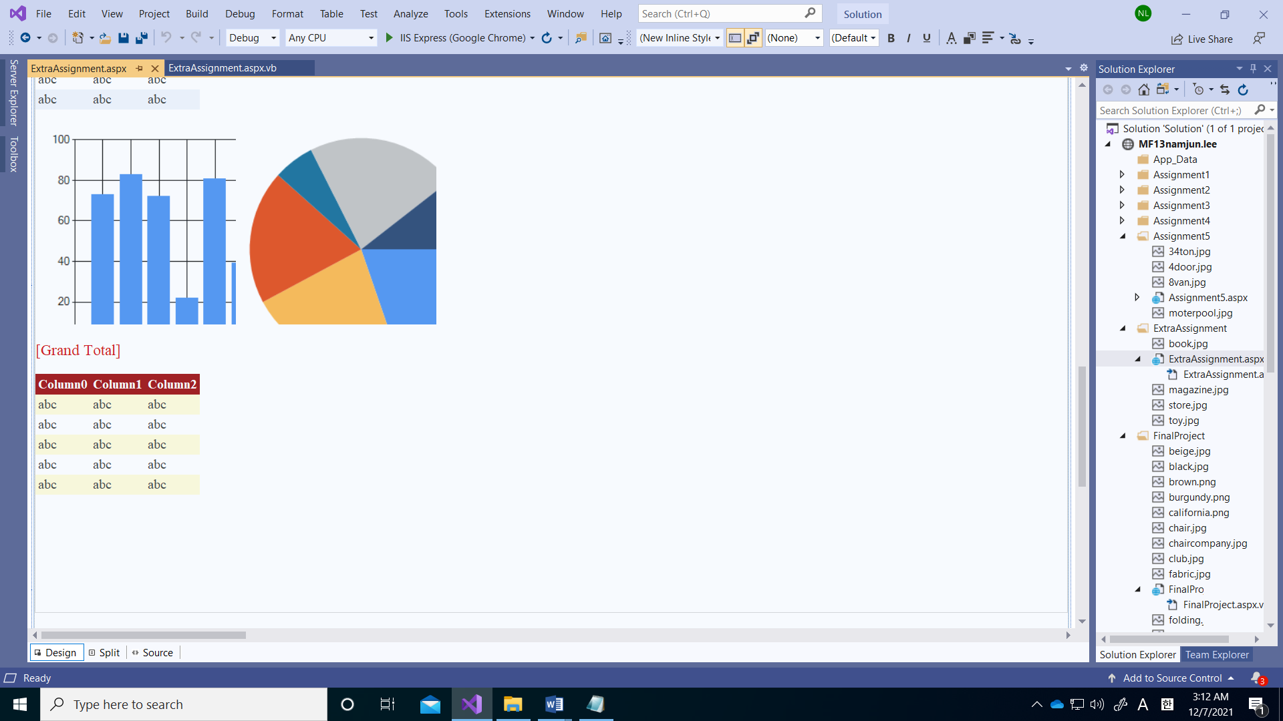

**Aspx.vb code:**

Imports System.Data

Partial Class ExtraAssignment_ExtraAssignment

Inherits System.Web.UI.Page

'This global variable tables is used as a data structure to store transaction data rows and two summary data tables.

Public Shared dtTransaction As New DataTable

Public Shared dtProduct As New DataTable

Public Shared dtGrandTotal As New DataTable

'three global integer variables to keep a running total to count of each items units sold, and count how many customers visited a day and member count.

Public Shared soldAll, costomerNum, member As Integer

'two global decimal variables updated to keep total include tax, total not include tax.

Public Shared taxAdd, taxPre As Decimal

Private Sub ExtraAssignment_ExtraAssignment_Init(sender As Object, e As EventArgs) Handles Me.Init

'if columns of either table were already created then exit, do not create them again

If dtGrandTotal.Columns.Count > 0 OrElse dtProduct.Columns.Count > 0 OrElse dtTransaction.Columns.Count > 0 Then Exit Sub

'This is an operation in which columns are added to the global data table. Names and data types for each column are specified. The first column is defined as an integer and an automatic number. There are 9 additional columns.

With dtTransaction.Columns

.Add("TransactionID", GetType(Integer))

.Add("PurchasedItem", GetType(String))

.Add("Price", GetType(Decimal))

.Add("Quantity", GetType(Decimal))

.Add("SubTotal", GetType(Decimal))

.Add("DiscountPrice", GetType(Decimal))

.Add("Tax", GetType(Decimal))

.Add("Total", GetType(Decimal))

.Add("Member", GetType(String))

End With

'The first column is defined as an integer and an automatic number

With dtTransaction.Columns("TransactionID")

.AutoIncrement = True

.AutoIncrementSeed = 1

.AutoIncrementStep = 1

End With

'This is an operation in which columns are added to the global summary data table. Names and data types for each column are specified. There are 3 additional columns.

With dtProduct.Columns

.Add("ProductType", GetType(String))

.Add("Price", GetType(Decimal))

.Add("Quantity", GetType(Decimal))

End With

'if calculations are going to be made in columns (such as running totals) then the values need to start at 0

With dtProduct

.Columns("Price").DefaultValue = 0

.Columns("Quantity").DefaultValue = 0

End With

'This is an operation in which columns are added to the global summary data table. Names and data types for each column are specified. There are 4 additional columns.

With dtGrandTotal.Columns

.Add("TotalCustomers", GetType(Decimal))

.Add("TotalPrice", GetType(Decimal))

.Add("TotalQuantity", GetType(Decimal))

.Add("Member", GetType(Decimal))

End With

'if calculations are going to be made in columns (such as running totals) then the values need to start at 0

With dtGrandTotal

.Columns("TotalCustomers").DefaultValue = 0

.Columns("TotalPrice").DefaultValue = 0

.Columns("TotalQuantity").DefaultValue = 0

.Columns("Member").DefaultValue = 0

End With

'row to store data in type of each product data table (3 rows)

For Each typeProduct As ListItem In RadioButtonList1.Items

Dim dr1 As DataRow = dtProduct.NewRow

dr1.Item("ProductType") = typeProduct.Text

dtProduct.Rows.Add(dr1)

Next

'row to store data in grand total data table only one

Dim dr2 As DataRow = dtGrandTotal.NewRow

dtGrandTotal.Rows.Add(dr2)

'used to see if the arrays are created and available (summary data tables; nothing recorded)

GridView2.DataSource = dtProduct

GridView2.DataBind()

GridView3.DataSource = dtGrandTotal

GridView3.DataBind()

End Sub

Protected Sub DrawCharts()

'create a total of each products sold (Quantity). these are properties of the overall chart control

With Chart1

.DataSource = dtProduct

.DataBind()

.Titles.Add("Total # Products Sold")

End With

'set the x and y axis labels

With Chart1.ChartAreas(0)

.AxisX.Title = "Products"

.AxisY.Title = "# Sold Quantity"

.Area3DStyle.Enable3D = True 'show 3D chart

End With

'withing the chart have series of data. (Compare sold each product type about quantity)

With Chart1.Series("Series1")

.ChartType = DataVisualization.Charting.SeriesChartType.Column

.XValueMember = "ProductType" 'these are columns in array - a dimension

.YValueMembers = "Quantity" 'this is the data to chart

.IsValueShownAsLabel = True

End With

'create a total of each products sold. these are properties of the overall chart control

With Chart2

.DataSource = dtProduct

.DataBind()

.Titles.Add("Sales by Products")

.Legends.Add("Legend1") ' the pie chart looks better with a legend

.Legends("Legend1").Enabled = True 'the legend is pulled from the X - dimension field specified

.ChartAreas(0).Area3DStyle.Enable3D = True

End With

'withing the chart have series of data. (Compare sold each product type about total price)

With Chart2.Series("Series1")

.ChartType = DataVisualization.Charting.SeriesChartType.Pie

.XValueMember = "ProductType" 'the dimension

.YValueMembers = "Price" ' the measure

.IsValueShownAsLabel = True

.IsVisibleInLegend = True

End With

End Sub

Protected Sub LinkButton1_Click(sender As Object, e As EventArgs) Handles LinkButton1.Click

'these next procedures allow the human to switch between sections of the program first link button

MultiView1.ActiveViewIndex = 0

End Sub

Protected Sub LinkButton2_Click(sender As Object, e As EventArgs) Handles LinkButton2.Click

'these next procedures allow the human to switch between sections of the program second link button

MultiView1.ActiveViewIndex = 1

DrawCharts() 'when the program user switches to view2 - refresh the charts which should be quick since the data is already pre-aggregated

End Sub

Protected Sub RadioButtonList1_SelectedIndexChanged(sender As Object, e As EventArgs) Handles RadioButtonList1.SelectedIndexChanged

'Image control in which the picture changes depending on the selected product.

MaintainScrollPositionOnPostBack = True

'If you choose a magazine from the list, you will see a picture of the magazine, if you choose a book, you will see a picture of the book, and if you choose a toy, you will see a picture of toy.

Select Case RadioButtonList1.SelectedIndex

Case 0

productImage.ImageUrl = "magazine.jpg"

productImage.Visible = True

Case 1

productImage.ImageUrl = "book.jpg"

productImage.Visible = True

Case 2

productImage.ImageUrl = "toy.jpg"

productImage.Visible = True

End Select

End Sub

Protected Sub calButton_Click(sender As Object, e As EventArgs) Handles calButton.Click

'When you click this button, it has the function of storing transactions for each customer in the data table and storing each summary data table

MaintainScrollPositionOnPostBack = True

'This is a local variable used to update the global variable at the top of this file.

Dim decTotal, quantity, price, currentTotal, tax, discount, priceQuan As Decimal

'if these test condition is true than show an error msg. and change the color of the list (red)

If RadioButtonList1.SelectedIndex < 0 Then

txtOutput.Text = "Please select the product"

RadioButtonList1.BorderWidth = 5

RadioButtonList1.BorderColor = Drawing.Color.Red

Exit Sub

Else 'it doesn't affect anything

RadioButtonList1.BorderColor = Drawing.Color.White

RadioButtonList1.BorderWidth = 1

End If

'if these test condition is true than show an error msg. and change the color of the list (red)

If quantityTextBox.Text = Nothing OrElse IsNumeric(quantityTextBox.Text) = False Then

txtOutput.Text = "Please enter the numeric number"

quantityTextBox.BorderWidth = 5

quantityTextBox.BorderColor = Drawing.Color.Red

Exit Sub

Else 'it doesn't affect anything

quantityTextBox.BorderColor = Drawing.Color.White

quantityTextBox.BorderWidth = 1

quantity = Convert.ToDecimal(quantityTextBox.Text)

End If

'if these test condition is true than show an error msg. and change the color of the list (red)

If priceTextBox.Text = Nothing OrElse IsNumeric(priceTextBox.Text) = False Then

txtOutput.Text = "Please enter the numeric number"

priceTextBox.BorderWidth = 5

priceTextBox.BorderColor = Drawing.Color.Red

Exit Sub

Else 'it doesn't affect anything

priceTextBox.BorderColor = Drawing.Color.White

priceTextBox.BorderWidth = 1

price = Convert.ToDecimal(priceTextBox.Text)

End If

'total price measurement'

decTotal = quantity * price

priceQuan = decTotal

'if member then yes else no

Dim strMem As String

'if the patron is not a member than ask them to sign up. if the patron is member than gives 20 percent discount'

If memberCheckBox.Checked = True Then

decTotal *= 0.8 'this gives 20 % discount'

discount = decTotal - decTotal * 0.8

strMem = "Yes"

member += 1

Else

strMem = "No"

End If

'number of customers who visited

costomerNum += 1

'Daily sales price'

taxAdd += (decTotal * 1.095) '9.5% tax rate

'Daily sales price excluding tax

taxPre += decTotal

'number of all items sold'

soldAll += quantityTextBox.Text

'current transaction

currentTotal += (decTotal * 1.095)

'only tax price

tax = (decTotal * 1.095) - decTotal

'show the first output on webpage; it include current transaction and what current item selected, number of items chose and price, and total revenue.'

txtOutput.Text = "Purchased Item: " & RadioButtonList1.SelectedItem.Text & vbNewLine & "Price: " & priceTextBox.Text.ToString & vbNewLine & "Quantity: " & quantityTextBox.Text.ToString & vbNewLine & "Price of Quantity: " & priceQuan.ToString("C0") & vbNewLine & vbNewLine & "Discount: (-)" & discount.ToString("C0") & vbNewLine & "Tax: " & tax.ToString("C0") & vbNewLine & vbNewLine & "Total: " & currentTotal.ToString("C0") & vbNewLine & vbNewLine & "Customer " & costomerNum.ToString & "'s transaction has been added to the data table!!!" & vbNewLine

Dim drT As DataRow = dtTransaction.NewRow 'new row in the data table

drT.Item("PurchasedItem") = RadioButtonList1.SelectedItem.Text 'purchased item name

drT.Item("Price") = priceTextBox.Text 'purchased item basic price

drT.Item("Quantity") = quantityTextBox.Text 'purchased item quantity

drT.Item("Tax") = tax 'tax rate

drT.Item("SubTotal") = priceQuan 'total purchased item

drT.Item("DiscountPrice") = discount 'discount price

drT.Item("Total") = currentTotal 'total price inculde tax

drT.Item("Member") = strMem 'count member

'row to store data

dtTransaction.Rows.Add(drT)

'Increase the total number of reservations when the button is clicked and performed

transactionLabel.Text = "Total of transactions: " & dtTransaction.Rows.Count

transactionLabel.Visible = True

GridView1.DataSource = dtTransaction

GridView1.DataBind() 'used to see if the array is created and available

'add rows to each column with product type summary data table

With dtProduct.Rows(RadioButtonList1.SelectedIndex)

.Item("Price") += currentTotal

.Item("Quantity") += quantityTextBox.Text

End With

'add rows to each column with grand total summary data table

With dtGrandTotal.Rows(0)

.Item("TotalCustomers") = dtTransaction.Rows.Count

.Item("TotalPrice") = taxAdd

.Item("TotalQuantity") = soldAll

.Item("Member") = member

End With

'used to see if the arrays are created and available (summary data tables)

GridView2.DataSource = dtProduct

GridView2.DataBind()

GridView3.DataSource = dtGrandTotal

GridView3.DataBind()

End Sub

Protected Sub clearButton_Click(sender As Object, e As EventArgs) Handles clearButton.Click

'clear the all output text boxes, list controls, images, text boxes (only enter the invoice setting)

MaintainScrollPositionOnPostBack = True

'clear list selected

RadioButtonList1.SelectedIndex = -1

'clear quantity box

quantityTextBox.Text = Nothing

'clear price box

priceTextBox.Text = Nothing

'clear product image

productImage.Visible = False

'clear member check box

memberCheckBox.Checked = False

'clear result ouptut

txtOutput.Text = Nothing

End Sub

End Class

**Run my webpage:**

